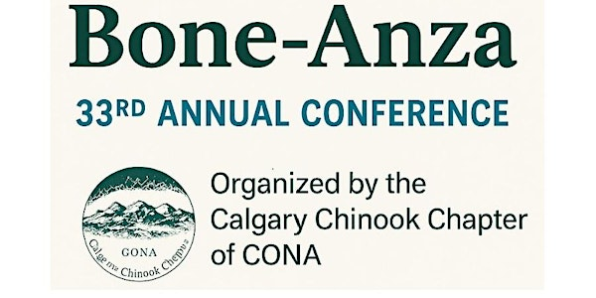
Date : Friday, October 31, 2025 (7:30am - 3pm)
Where: Radisson Hotel and Conference Center
Calgary Airport (6620 36th Street NE Calgary, AB)

To Register Click Link:
Bone-Anza Tickets, Fri, Oct 31, 2025 at 7:30 AM | Eventbrite

